WRITING, SIMPLIFYING AND ORDERING FRACTIONS
Pearson Edexcel - Monday 8 June 2020 - Paper 3 (Calculator) Foundation Tier

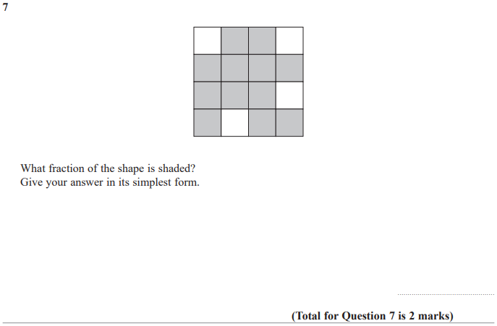

Pearson Edexcel - Thursday 24 May 2018 - Paper 1 (Non-Calculator) Foundation Tier

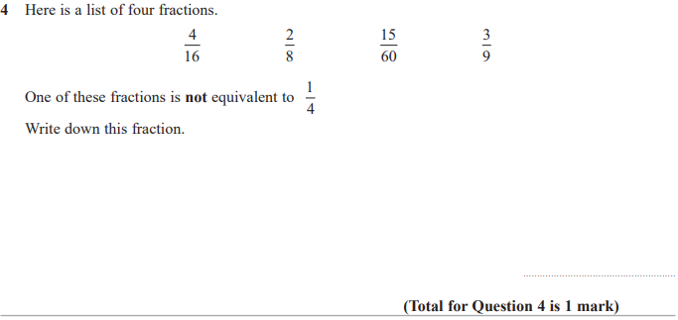

Pearson Edexcel – Specimen 1 - Paper 2 (Calculator) Foundation Tier
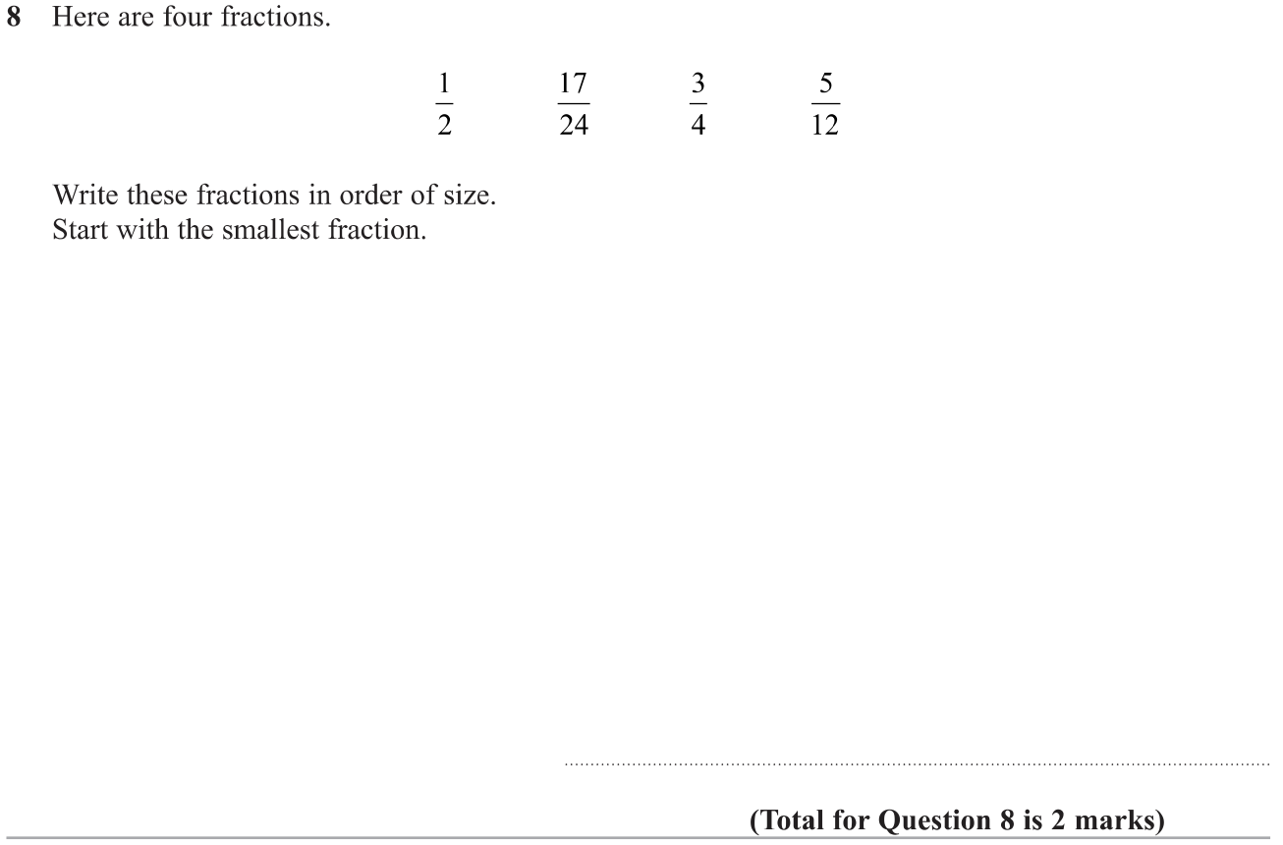

Pearson Edexcel – Sample Paper 1 (Non-Calculator) Foundation Tier

OCR Tuesday 5 November 2019 – Morning (Calculator) Foundation Tier
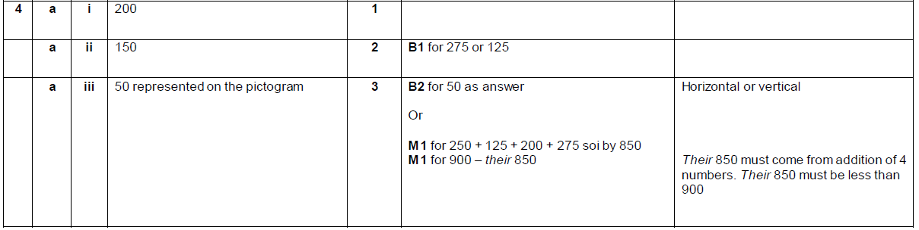

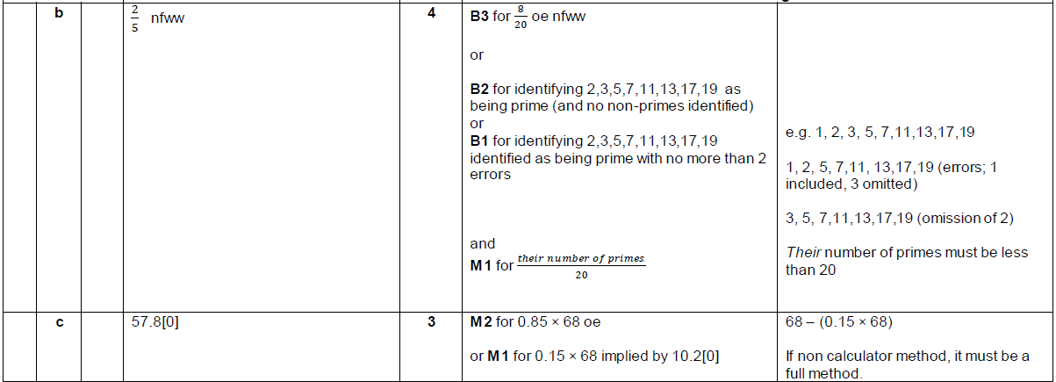

OCR Monday 12 November 2018 – Morning (Calculator) Foundation Tier
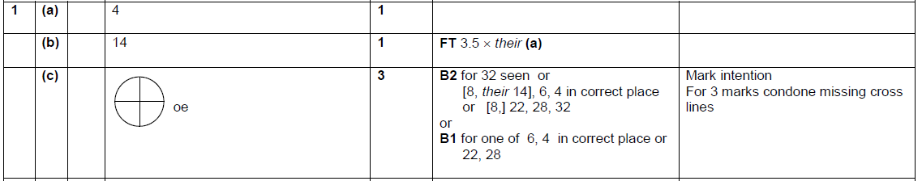

Pearson Edexcel – Sample Papers - Paper 1 (Non-Calculator) Foundation Tier

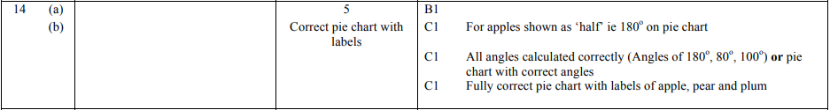
OCR Sample Question Paper 1 – Morning/Afternoon (Calculator) Foundation Tier

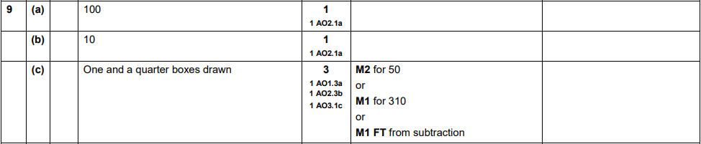

AQA Tuesday 19 May 2020 – Morning (Non-Calculator) Foundation Tier

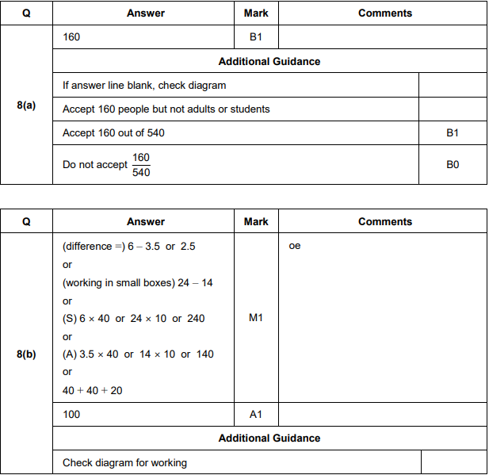

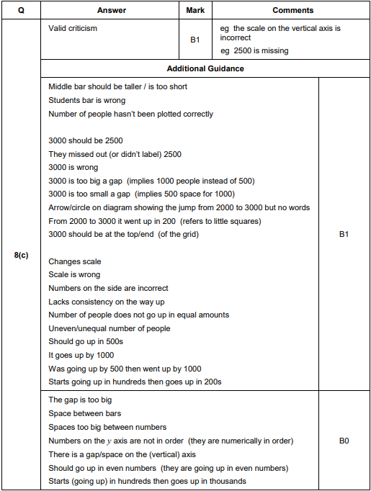

AQA Thursday 11 June 2019 – Morning (Calculator) Foundation Tier

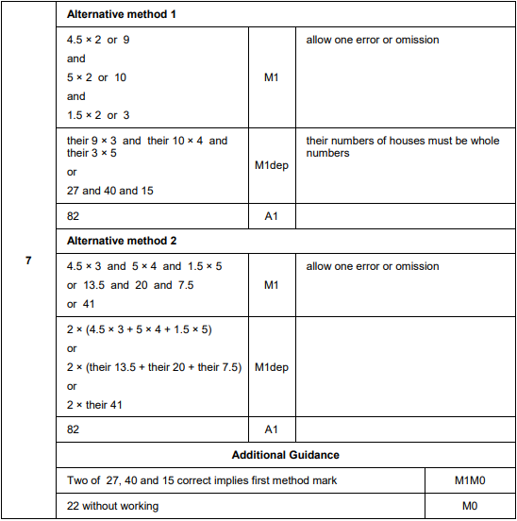

AQA Thursday 8 June 2017– Morning (Calculator) Foundation Tier

